**Create VPC**

Login to aws console

* Under Services and search for VPC

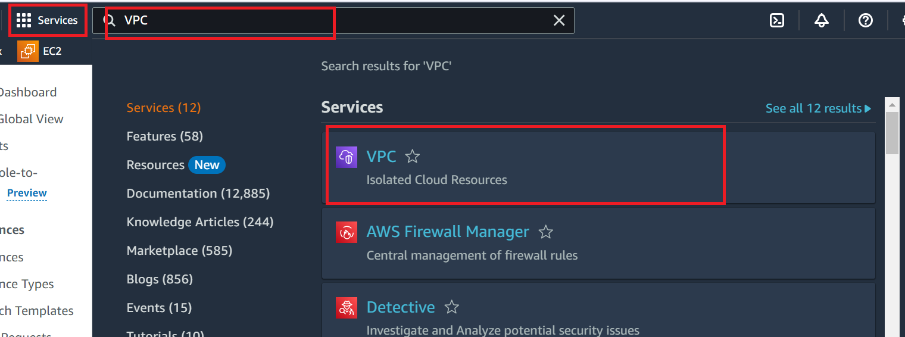

Click on VPC, your vpc options

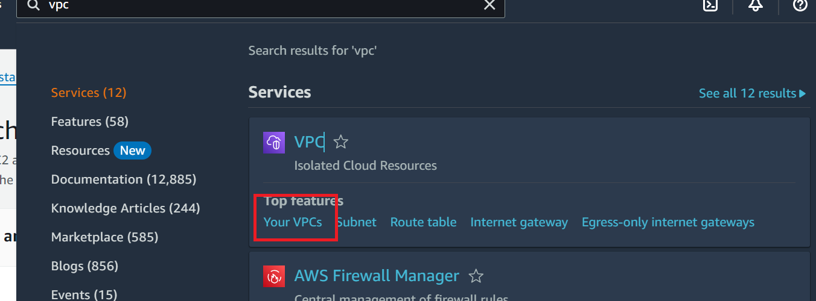

Click on Create VPC

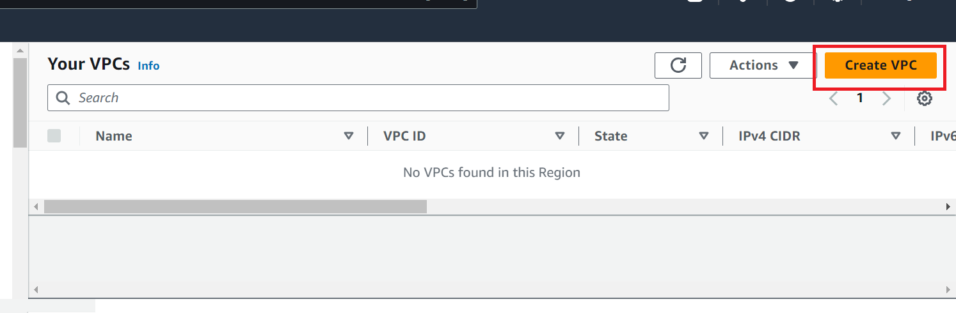

Select the ipv4 range

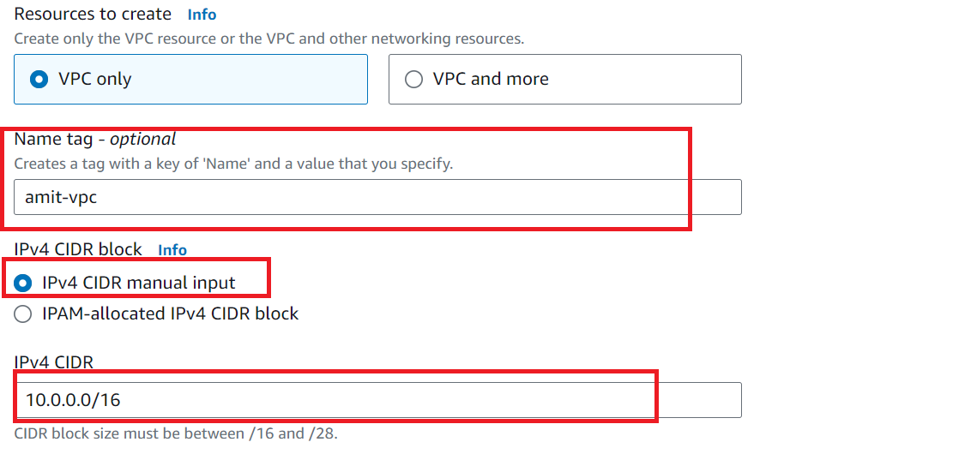

Create VPC

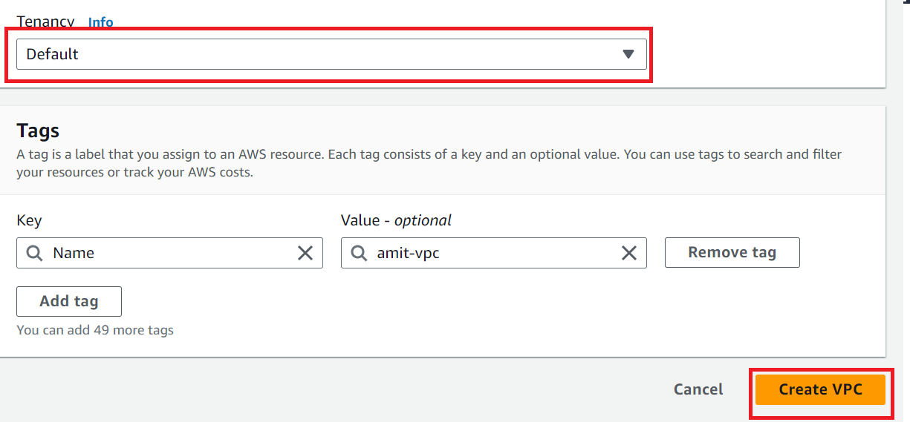

A subnet is a range of IP addresses in your VPC. After creating a VPC, you can add one or more subnets in each Availability Zone

After creating VPC create subnet for VPC

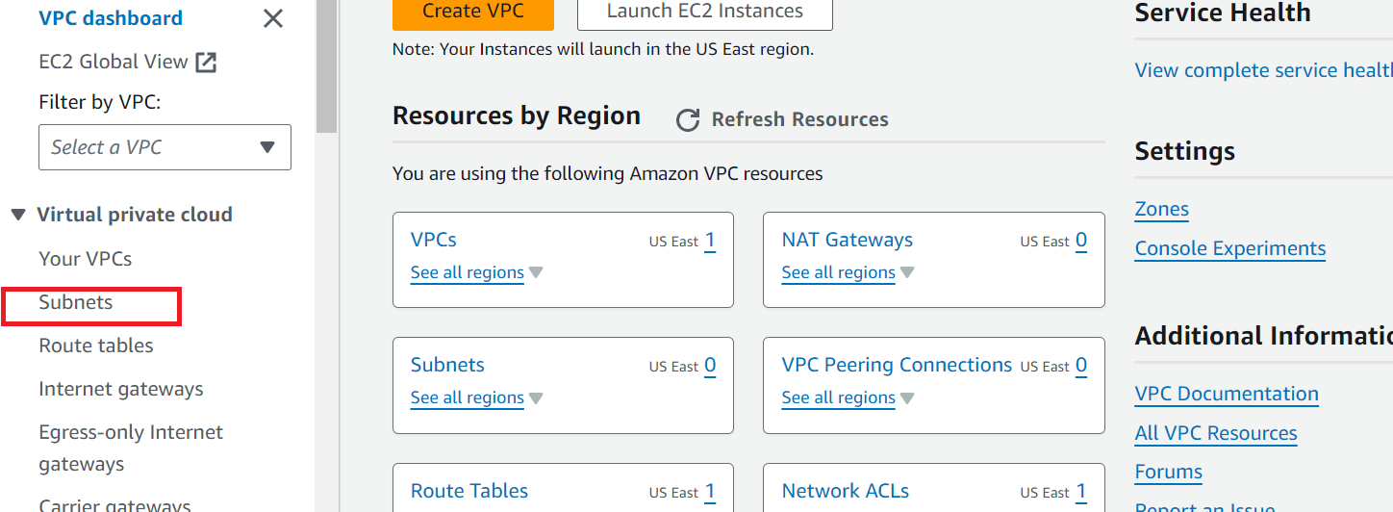

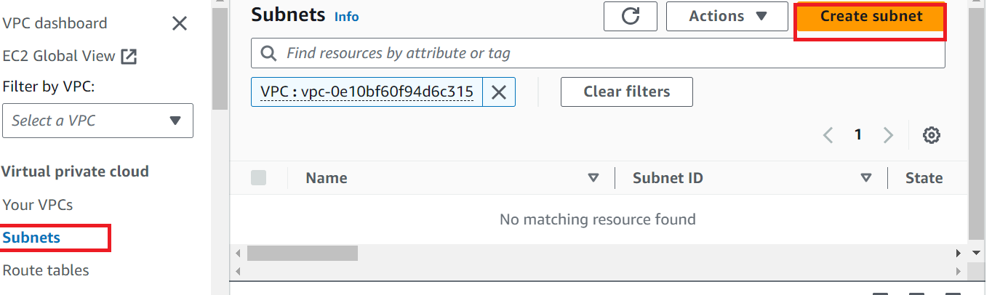

Select the VPC ID

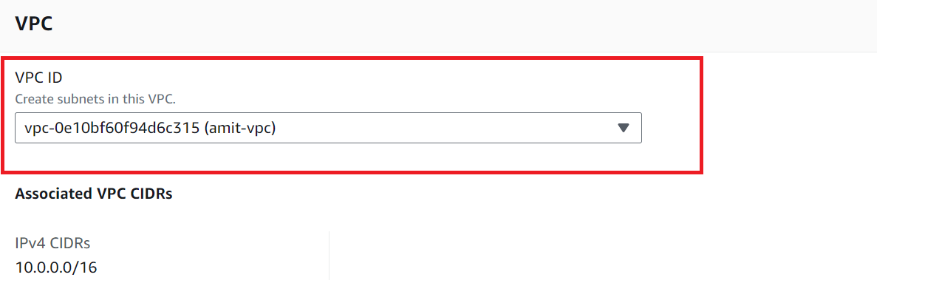

Select the subnet Details: Name, VPC ,subnet range

**Note: Since VPC range 10.0.0.0/16 : Subnet range can be 10.0.0.0/24**

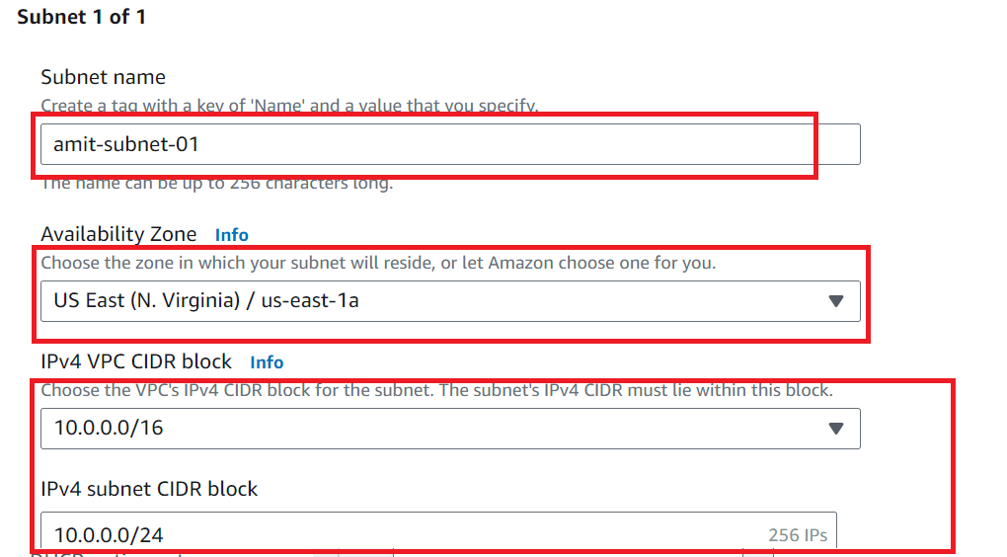

Create Subnet

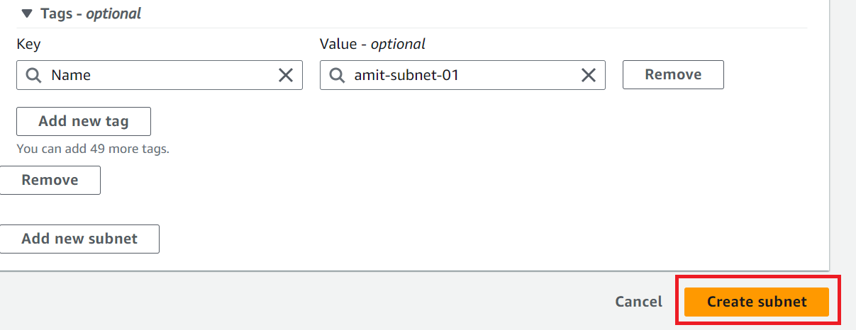

Create Route Table

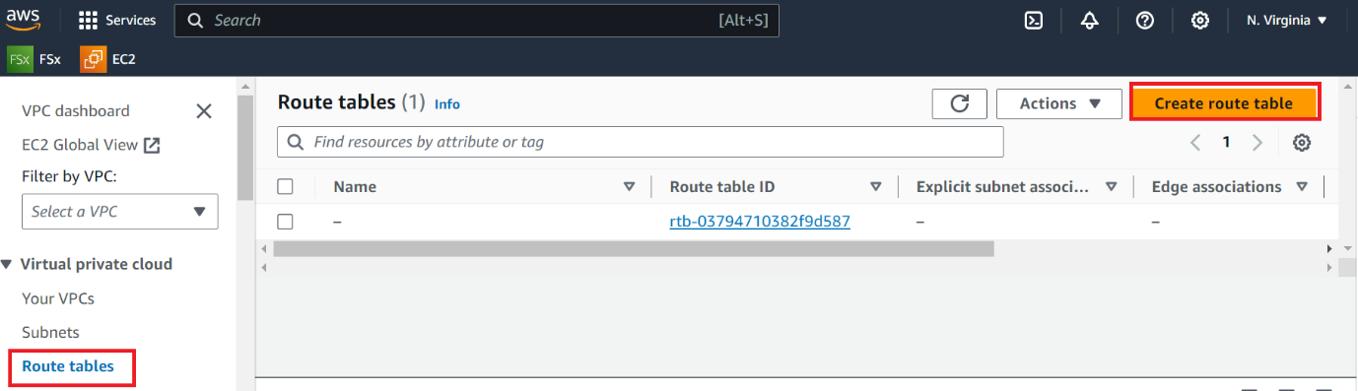

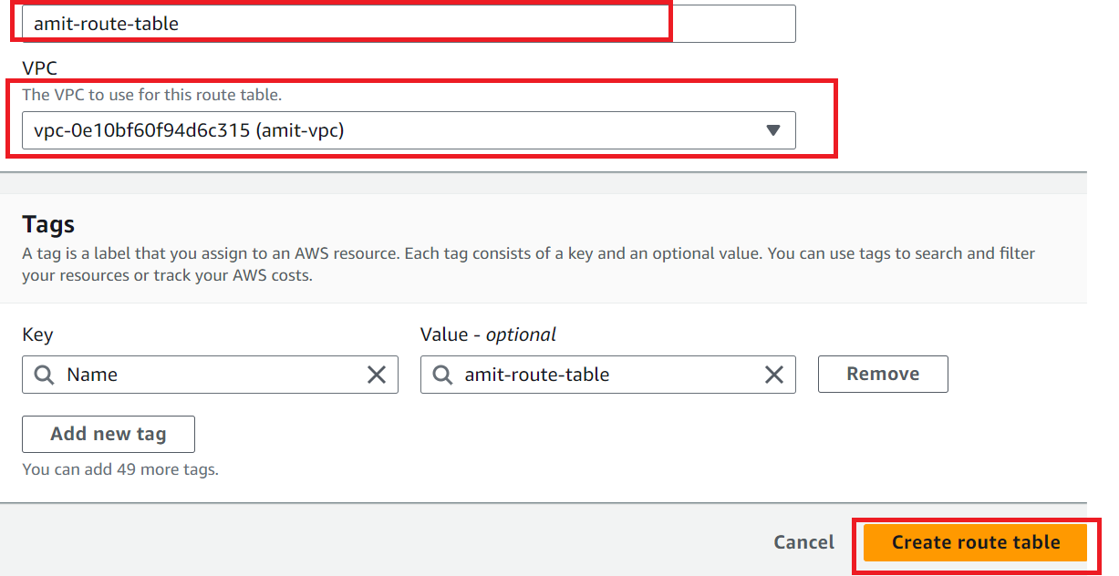

Associate the subnet in route table

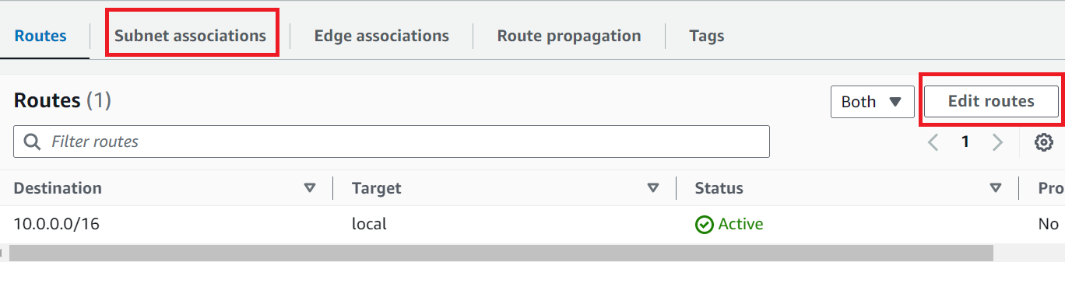

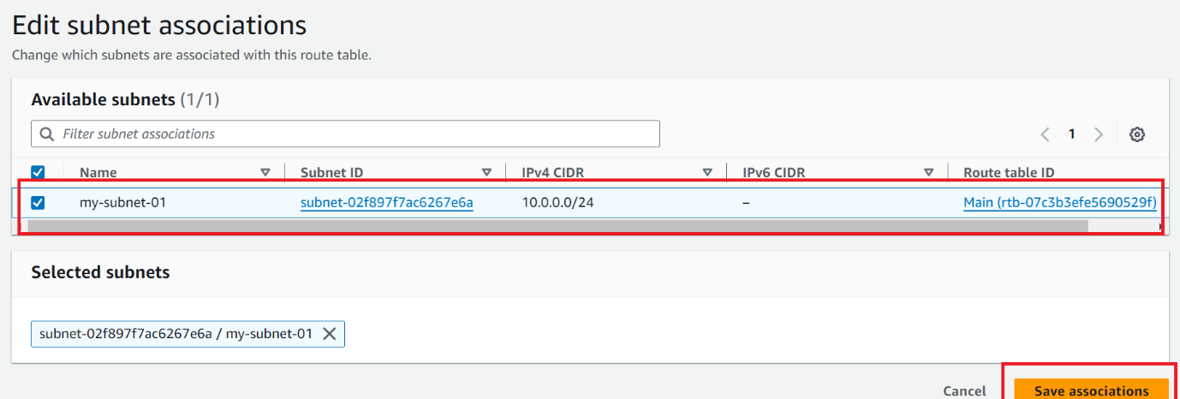

Create Internet Gateway

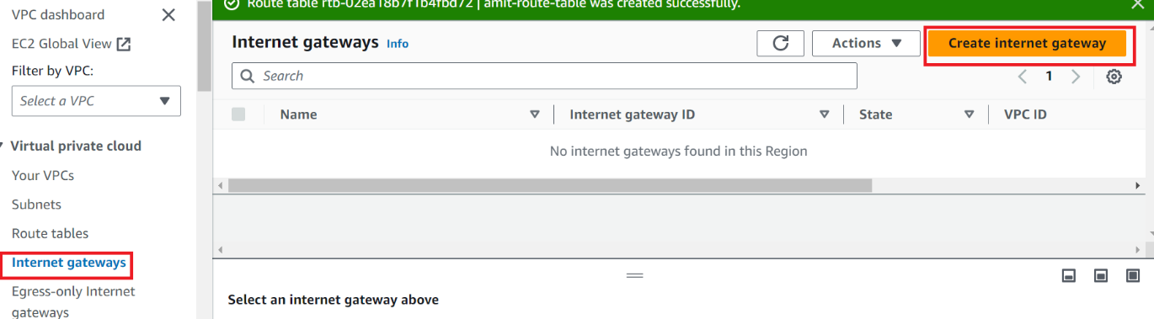

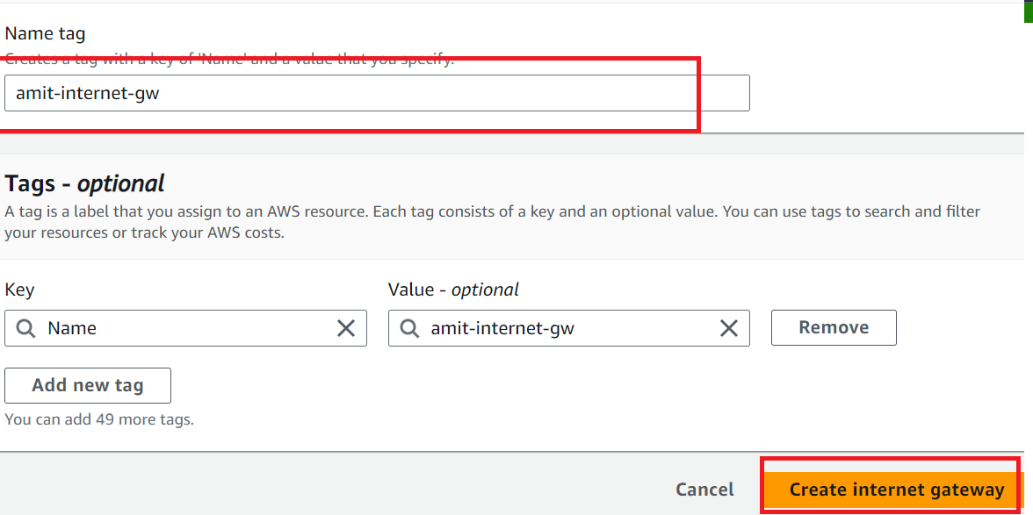

Attach Internet gateway to VPC

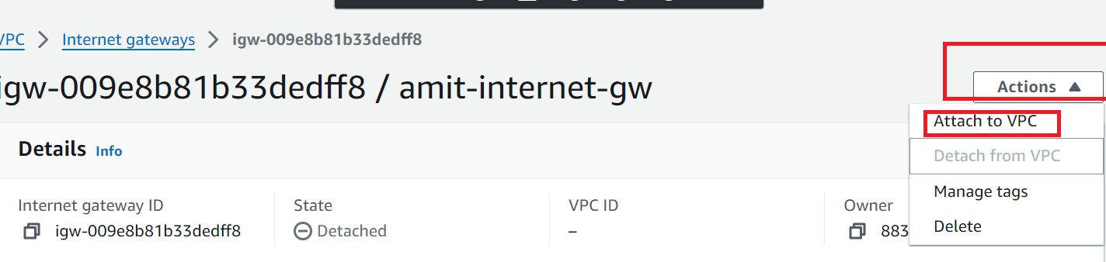

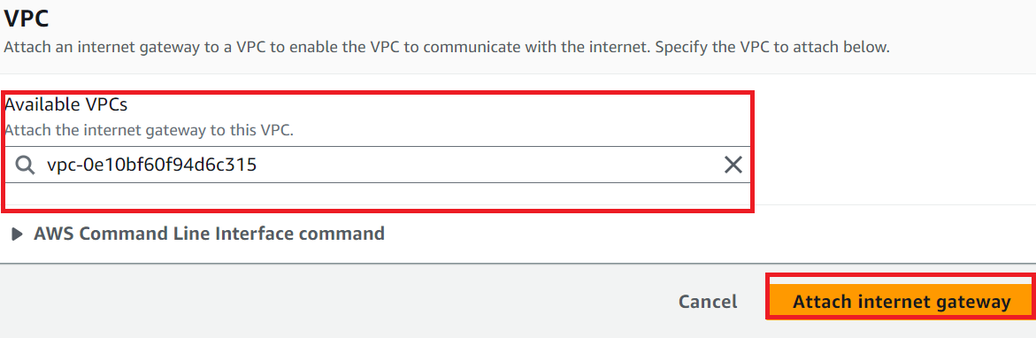

Edit Route Table for internet gateway

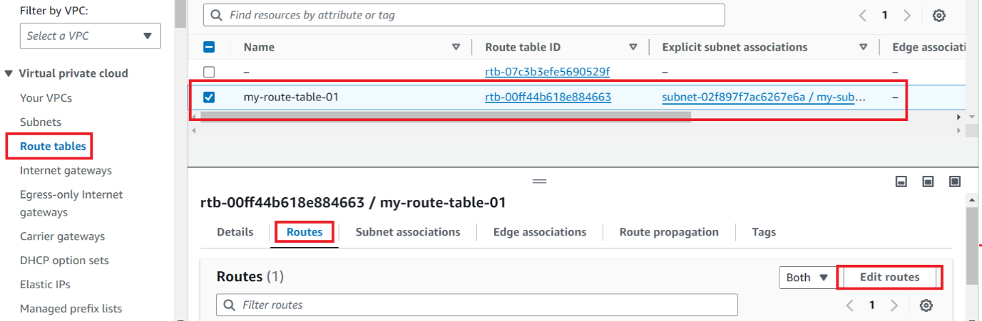

Add routes

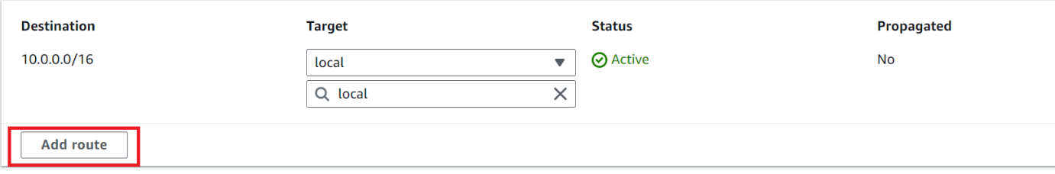

Search and add the internet gateway

